

parul universitys

FACULTY OF ENGINEERING AND TECHNOLOGY

BACHELOR OF TECHNOLOGY

MOBILE APPLICATION DEVELOPMENT LABORATORY (303105379)

VI SEMESTER

Computer Science and Engineering Department

Laboratory Manual Session 2024-25

**CERTIFICATE**

This is to certify that

Mr. SHIVANSHU SHUKLA with enrolment no.

2203051050539 has successfully completed

his/her laboratory experiments in the **Mobile Application Development (303105379)** from the department of **COMPUTER SCIENCE & ENGINEERING** during the academic year 2024-2025.



Date of Submission:......................... Staff In charge:...........................

Head Of Department:......................................



**MOBILE APPLICATION DEVELOPMENT PRACTICAL BOOK COMPUTER SCIENCE & ENGINEERING DEPARTMENT**

**PREFACE**

We are delighted to present the first edition of the *Mobile Application Development Practical Book* for BTech 6th semester students at Parul University.

The theory and laboratory courses in Mobile Application Development (MAD) at Parul University, Waghodia, Vadodara, are meticulously designed to bridge theoretical knowledge with practical application. In the theory classes, students gain foundational insights into the subject, while the laboratory sessions offer hands-on experience to implement the concepts learned. The primary goal of the MAD laboratory course is to enable students to *Learn Mobile Application Development through Experimentation.*

This *MAD Practical Book* provides a comprehensive guide to all experiments included in the laboratory syllabus. Each experiment is crafted to address key problems in different areas of MAD and introduces students to practical implementations and real-world applications. The book offers detailed explanations of the fundamental concepts, problem analysis techniques, and guidelines for interpreting and discussing results.

We extend our gratitude to the authors and publishers of the resources referenced during the creation of this practical book. We hope that this *MAD Practical Book* will be a valuable resource for students and fulfill its intended purpose of enhancing their learning experience.

**TABLE OF CONTENT**



|  |  |  |  |  |  |  |  |
| --- | --- | --- | --- | --- | --- | --- | --- |
| **Sr. No** | **Experiment Title** | **Page No** | | **Date of Start** | **Date of Completion** | **Sign** | **Marks (out of 10)** |
| **From** | **To** |
| **1.** | Compare various operating systems with Android OS. |  |  |  |  |  |  |
| **2.** | Install and configure java development kit (JDK), android studio and android SDK |  |  |  |  |  |  |
| **3.** | Configure android development tools (ADT) plug-in and create android virtual device |  |  |  |  |  |  |
| **4.** | Develop a program to display Hello World on screen. |  |  |  |  |  |  |
| **5.** | Develop a program to implement linear layout and absolute layout. |  |  |  |  |  |  |
| **6** | Develop a program to implement frame layout, table layout and relative layout. |  |  |  |  |  |  |
| **7.** | Create an application that takes the name from a text box and shows hello message along  with the name entered in text box,  when the user clicks the OK button |  |  |  |  |  |  |
| **8.** | Create a screen that has input boxes for User Name, Password,  Address, Gender (radio  buttons for male and female), Age (numeric), Date of Birth (Date Picket), State (Spinner)  and a Submit button. On clicking the submit button, print all the data below the Submit  Button (use any layout) |  |  |  |  |  |  |
| **9.** | Design an android application to create page using Intent and one Button and pass the Values from one Activity to second Activity |  |  |  |  |  |  |
| **10** | Design an android application Send SMS using Intent. |  |  |  |  |  |  |
| **11** | Create an android application using Fragments. |  |  |  |  |  |  |
| **12.** | Design an android application Using Radio button. |  |  |  |  |  |  |
| **13.** | Design an android application for menu. |  |  |  |  |  |  |

**PRACTICAL NO: 1**



**AIM**: Compare various operating systems with Android OS.

* Android:
* Android is a software package and Linux based operating system for mobile devices such as tablet computers and smartphones.
* It is developed by Google and later the OHA (Open Handset Alliance). Java language is mainly used to write the android code even though other languages can be used.
* The goal of android project is to create a successful real-world product that improves the mobile experience for end users.
* Android offers a unified approach to application development for mobile devices which means developers need only develop for Android, and their applications should be able to run on different devices powered by Android.
* The first beta version of the Android Software Development Kit (SDK) was released by Google in 2007 where as the first commercial version, Android 1.0, was released in September 2008.
* The source code for Android is available under free and open-source software licenses. Google publishes most of the code under the Apache License version 2.0 and the rest, Linux kernel changes, under the GNU General Public License version 2.
* There are many code names of android such as Lollipop, KitKat, Jelly Bean, Ice cream Sandwich, Froyo, Eclair, Donut etc.
* Why Android?

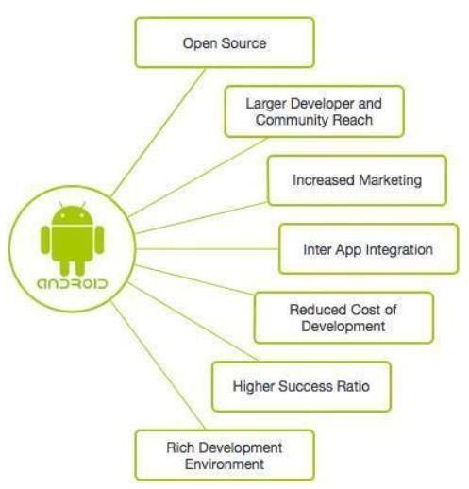

* Features of Android:



* + After learning what is android, let's see the features of android. The important features of android are given below:

1. It is open-source.
2. Anyone can customize the Android Platform.
3. There are a lot of mobile applications that can be chosen by the consumer.
4. It provides many interesting features like weather details, opening screen, live RSS (Really Simple Syndication) feeds etc.
5. It provides support for messaging services (SMS and MMS), web browser, storage (SQLite), connectivity (GSM, CDMA, Blue Tooth, Wi-Fi etc.), media, handset layout etc.
   * Categories of Android applications:
     + There are many android applications in the market. The top categories are:

i. Entertainment ii. Tools iii. Communication iv. Productivity

v. Personalization vi. Music and Audio vii. Social viii. Media and Video ix. Travel and Local etc.

* Windows Operation System:
  + Microsoft Windows is an operating system that was developed by Microsoft

Cooperation. It is one of the most well-known operating systems in the world. It employs a graphical user interface (GUI).

* + It enables users to save data, watch videos, run applications, play games, and connect to the Internet.
  + The first version of Microsoft Windows is version 1.0, which was released on November 10, 1983. Microsoft Windows is available in various flavors, including Windows XP, Vista, Windows 95, Windows 7, 8, 10, 11, and 12.
  + The first business-oriented Windows operating system version was released in 1993, known as Windows NT 3.1.
  + Windows launched the next versions, including Windows 3.5, 4/0, and Windows 2000. It developed several versions of Windows XP for home and the commercial environment when it was released in 2001. It was made with standard x86

hardware, including AMD and Intel processors. As a result, it could run on various hardware, including HP, Dell, Sony, and custom-built PCs.

* Linux OS:
  + Linux is a powerful and flexible family of operating systems that are free to use and share. It was created by a person named Linus Torvalds in 1991.
  + What’s cool is that anyone can see how the system works because its source code is open for everyone to explore and modify. This openness encourages people from all over the world to work together and make Linux better and better. Since its beginning, Linux has grown into a stable and safe system used in many different things, like computers, smartphones, and big supercomputers.
  + It’s known for being efficient, meaning it can do a lot of tasks quickly, and it’s also cost- effective, which means it doesn’t cost a lot to use. As technology keeps moving forward, Linux will keep evolving and staying important in the world of computers.



* iOS Operating System:
* iOS is an abbreviation for the iPhone operating system. iOS is the operating system that runs on many of Apple's mobile devices, including the iPhone and iPod Touch.
* It is the world's second most popular mobile OS, trailing only Android.
* It is the basis for three other Apple operating systems: iPadOS, tvOS, and watchOS. It is a part of proprietary software. Some are open source under the Apple Public Source License and other licenses.
* The iOS OS was first released in 2007 for the first-generation iPhone and has since been updated to support more Apple devices, including the iPod Touch and iPad. Apple's App Store had over 2.1 million iOS apps as of March 2018, with 1 million unique to iPads.
* Apple releases a new major version of iOS every year. On September 20, 2021, the current stable version, iOS 15, was released to the public.
* Comparison between various Operating System:

|  |  |  |  |  |  |  |
| --- | --- | --- | --- | --- | --- | --- |
| Aspect | Android OS | | Windows OS | Linux OS | iOS | |
| Development Company | Google | | Microsoft | Various | Apple | |
| Kernel | Linux | | Windows NT | Linux | XNU (Hybrid) | |
| User Interface | Material Design | | Modern UI | Varied (Depends on Desktop  Environment) | Flat Design | |
| App Ecosystem | Google Store | Play | Microsoft Store | Varied (Repositories, Software  Center, etc.) | Apple Store | App |
| Programming Language | Java, Kotlin | | C#, C++, .Net | Various (C, C++, Python,  etc.) | Objective-C, Swift | |
| Security | Varied (Depends on | | High (with regular updates) | Varied (Depends on  Distribution) | High (with regular updates) | |
|  | OEM  updates) | and |  |  |  | |
| Licensing Model | Open Source (AOSP) | | Proprietary (Commercial) | Open Source (Most distributions) | Closed Source (Proprietary) | |
| Development Tools | Android Studio, SDK | | Visual Studio,  .NET  Framework | Various (GCC, Clang, etc.) | Xcode,  Swift Playgrounds | |

# PRACTICAL NO: 2



Aim: Install and configure java development kit (JDK), android studio and android SDK.

* + **JDK Installation:**

1. 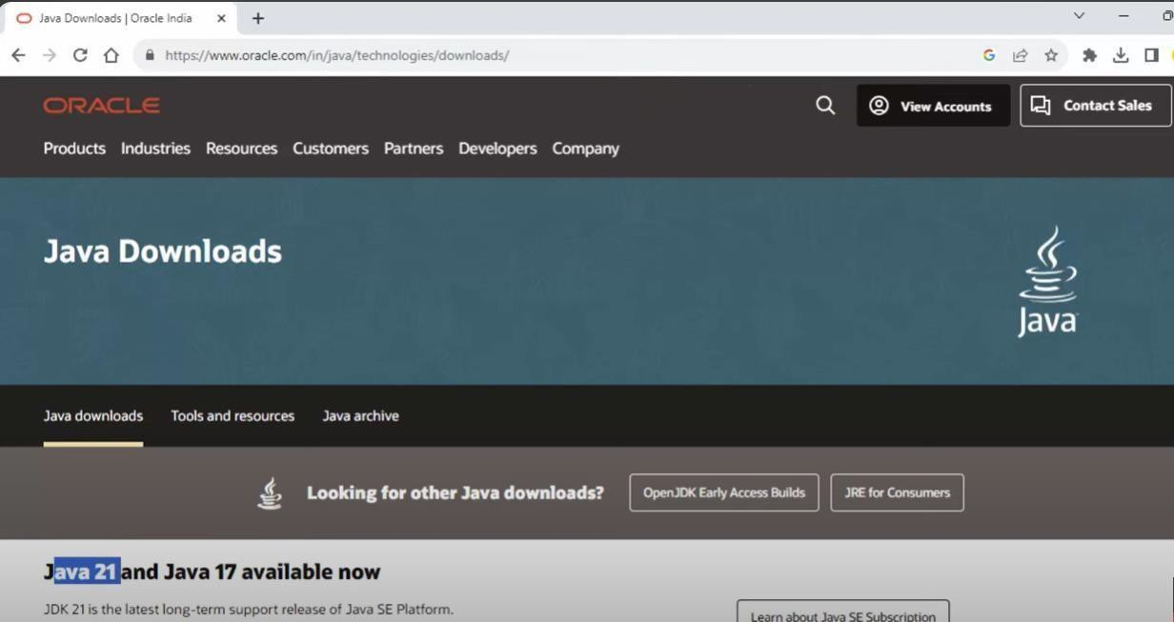**Download the JDK from the official site of Oracle “Java Downloads | Oracle India” .**
2. **Once downloaded open the setup and follow the steps.**

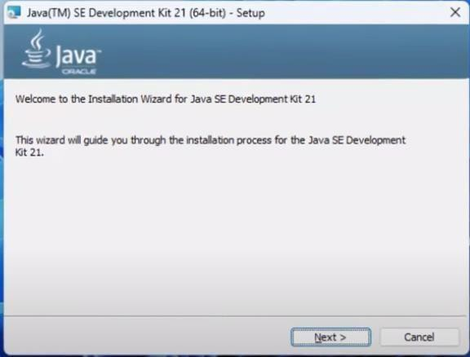



1. **Choose the destination folder where you want to install the jdk. Click on next this will start the installation process.**

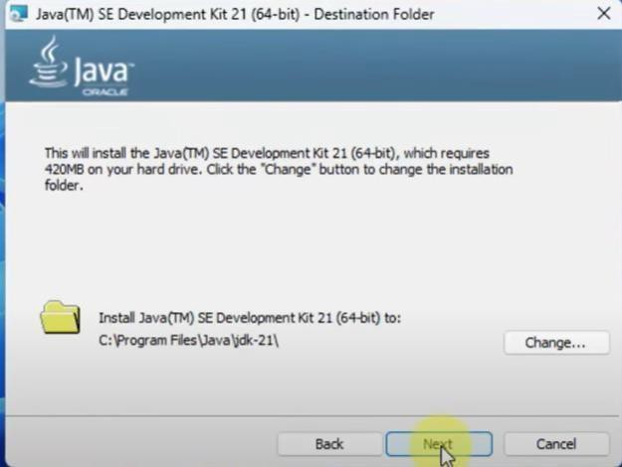

1. **Once done installing it will show the following pop-up.**

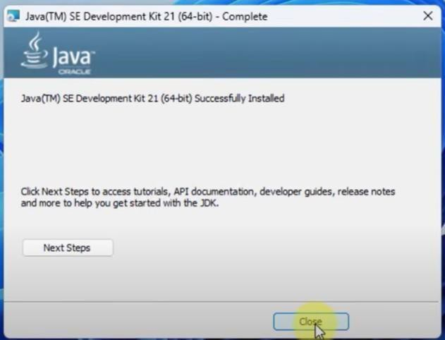

* + **Android Studio Installation:**

1. **Open the site “**[**Download Android Studio & App Tools**](https://developer.android.com/studio?gad_source=1&gclid=EAIaIQobChMI0rrvyOfBhAMVVdEWBR0C-Q4cEAAYASAAEgKfIfD_BwE&gclsrc=aw.ds&authuser=1)[**-**](https://developer.android.com/studio?gad_source=1&gclid=EAIaIQobChMI0rrvyOfBhAMVVdEWBR0C-Q4cEAAYASAAEgKfIfD_BwE&gclsrc=aw.ds&authuser=1)[**Android Developers”**](https://developer.android.com/studio?gad_source=1&gclid=EAIaIQobChMI0rrvyOfBhAMVVdEWBR0C-Q4cEAAYASAAEgKfIfD_BwE&gclsrc=aw.ds&authuser=1) **and click on the download now option to start the download for android studio.**



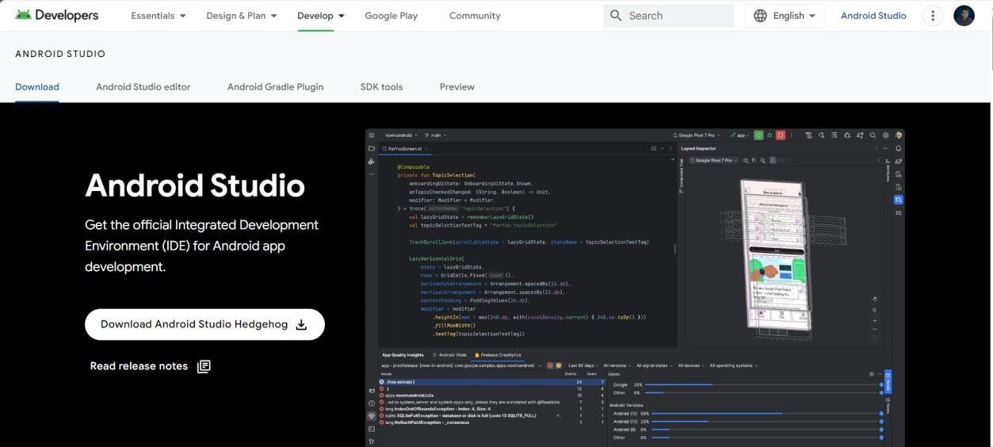

1. **Once downloaded open the android studio setup and the following window will popup.**

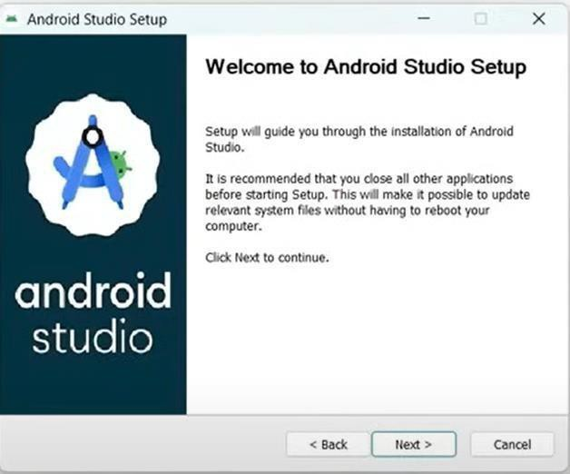

1. 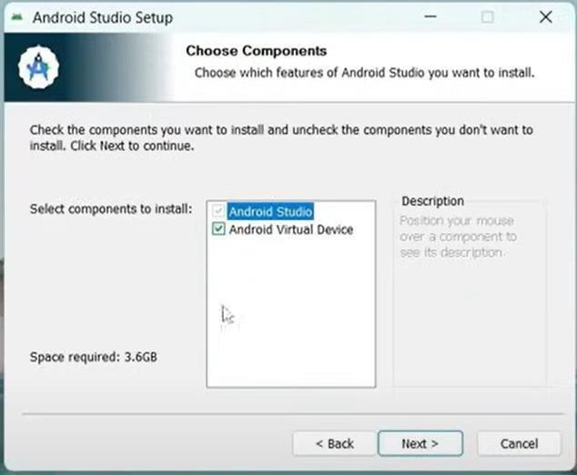**Choose the component you want to install in android studio and click on next**



1. **Select the installation location and click on next to start the installation.**

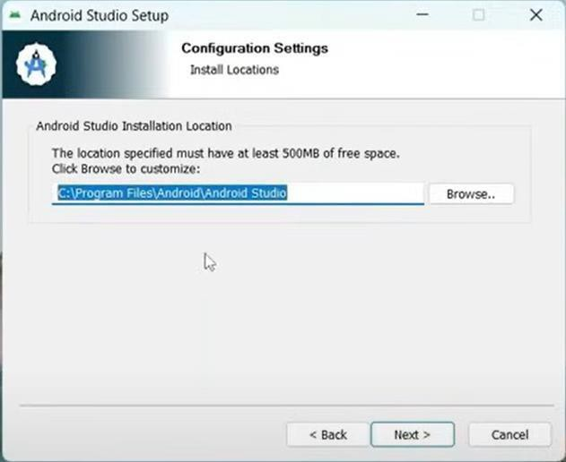

1. 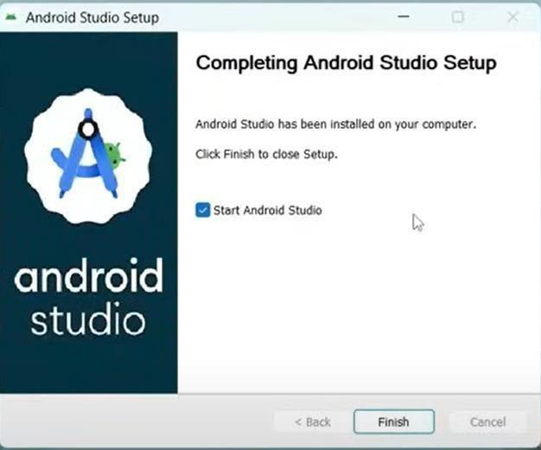**Once done installation you are all-set to open android studio and start developing your android apps.**



# PRACTICAL 3



## Aim: Configure android development tools (ADT) plug-in and create android virtual device.

On starting android studio for first time the setup android development tools will open up.

* Follow the steps to configure the ADT and create a virtual device:

1. This is the first screen you will see when you open android studio for the first time.

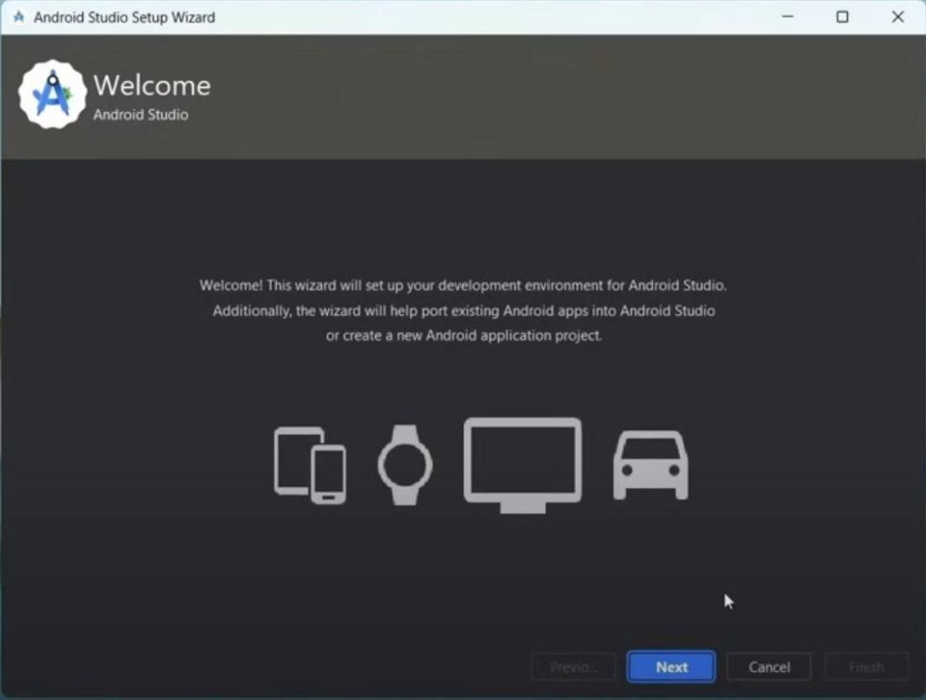

1. Select the installation type for android studio.

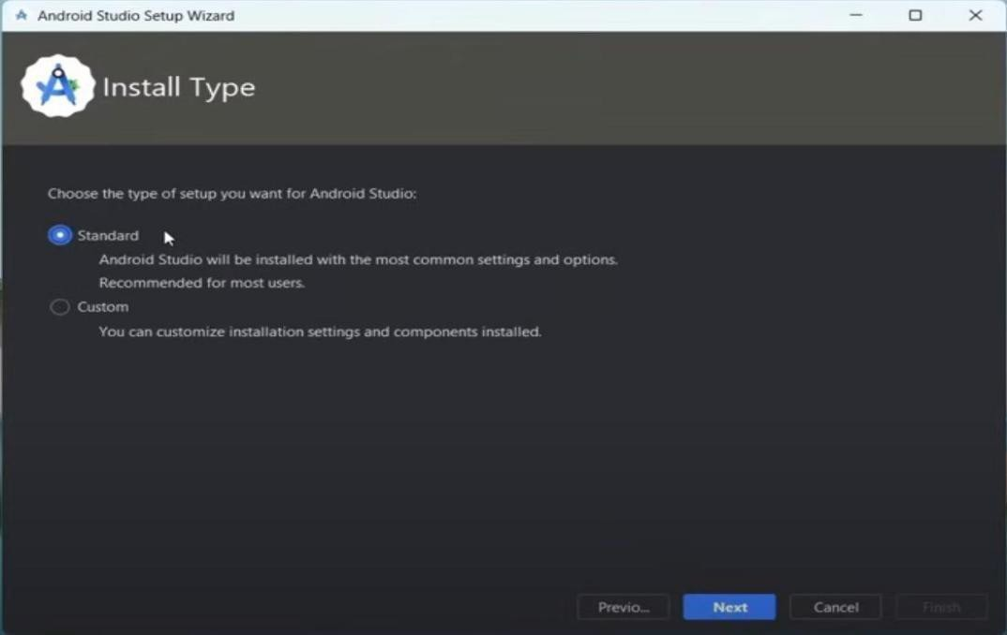



1. Select the components you want to install.

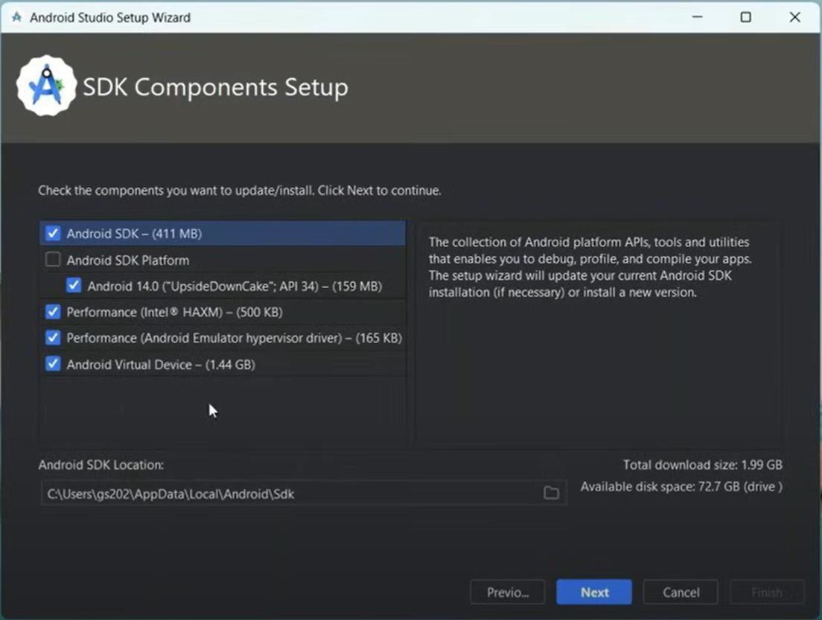

1. Click on next, agree the licenses and click on next this will start the installation for the components.

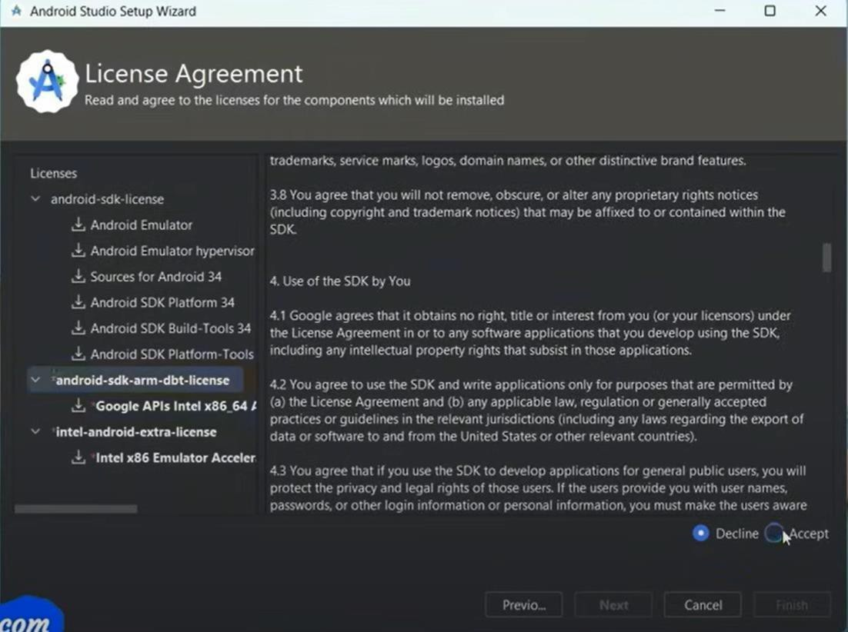



1. Click on finish and you are ready.

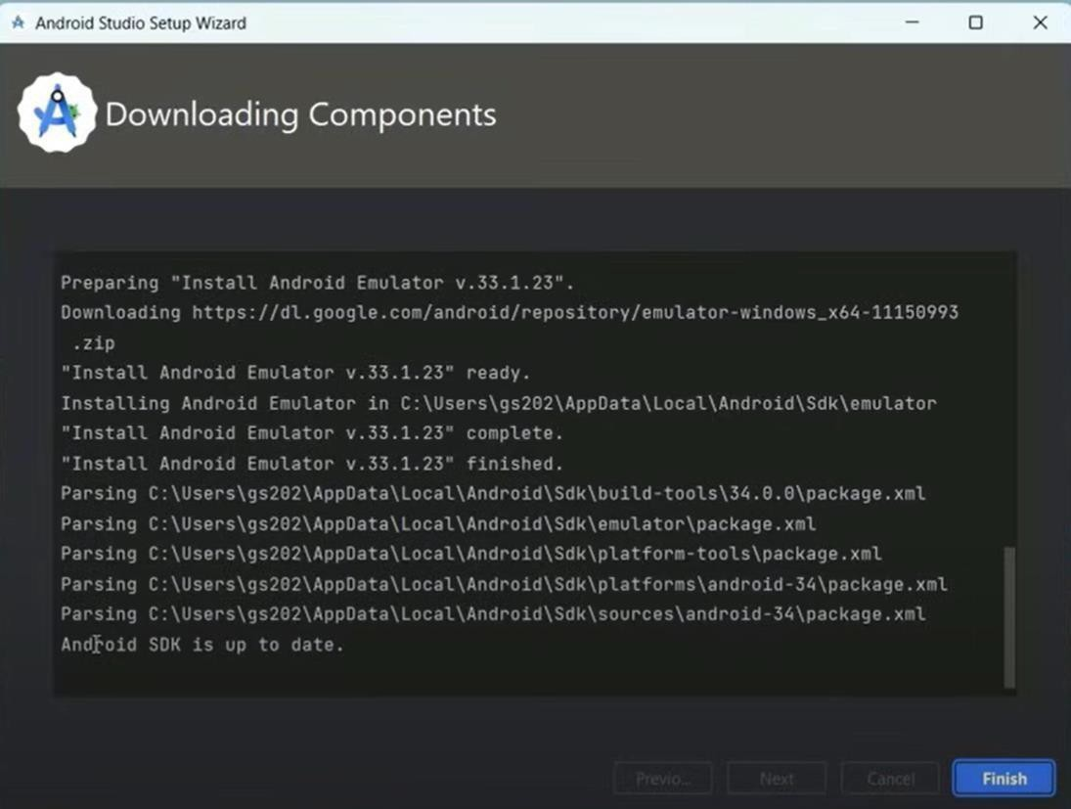

* + Steps to setup an AVD:

1. In Android Studio, launch the Android Virtual Device Manager by selecting Tools, then Android, and then AVD Manager.
2. In the Your Virtual Devices screen, click Create Virtual Device.
3. In the Select Hardware screen, select a phone device, such as Pixel, and then click Next.

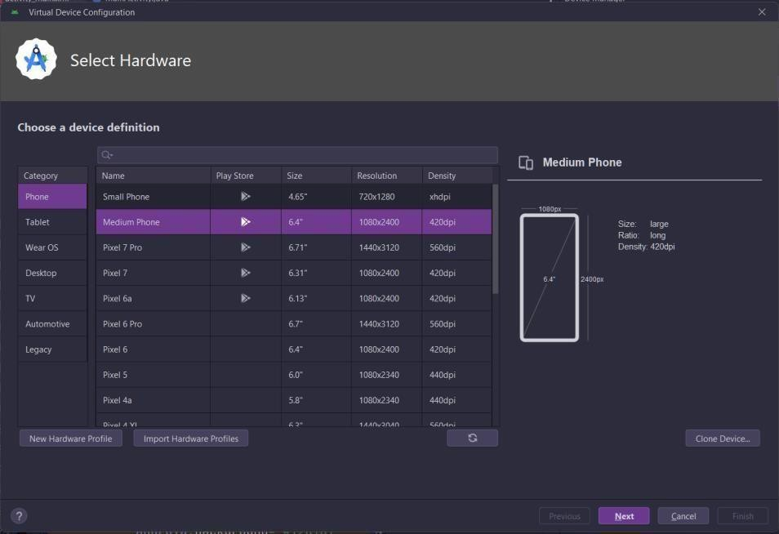

1. In the System Image screen, click Download for one of the recommended system images. Agree to the terms to complete the download.



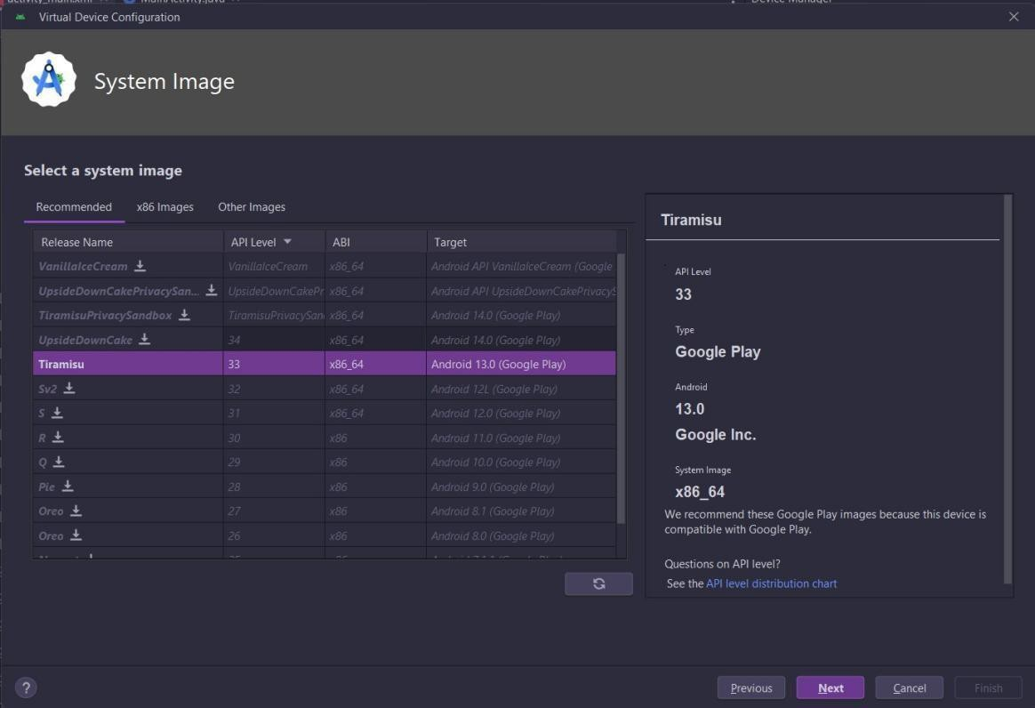

1. After the download completes, select the system image from the list and click Next.
2. On the next screen, leave all the configuration settings unchanged and click Finish.

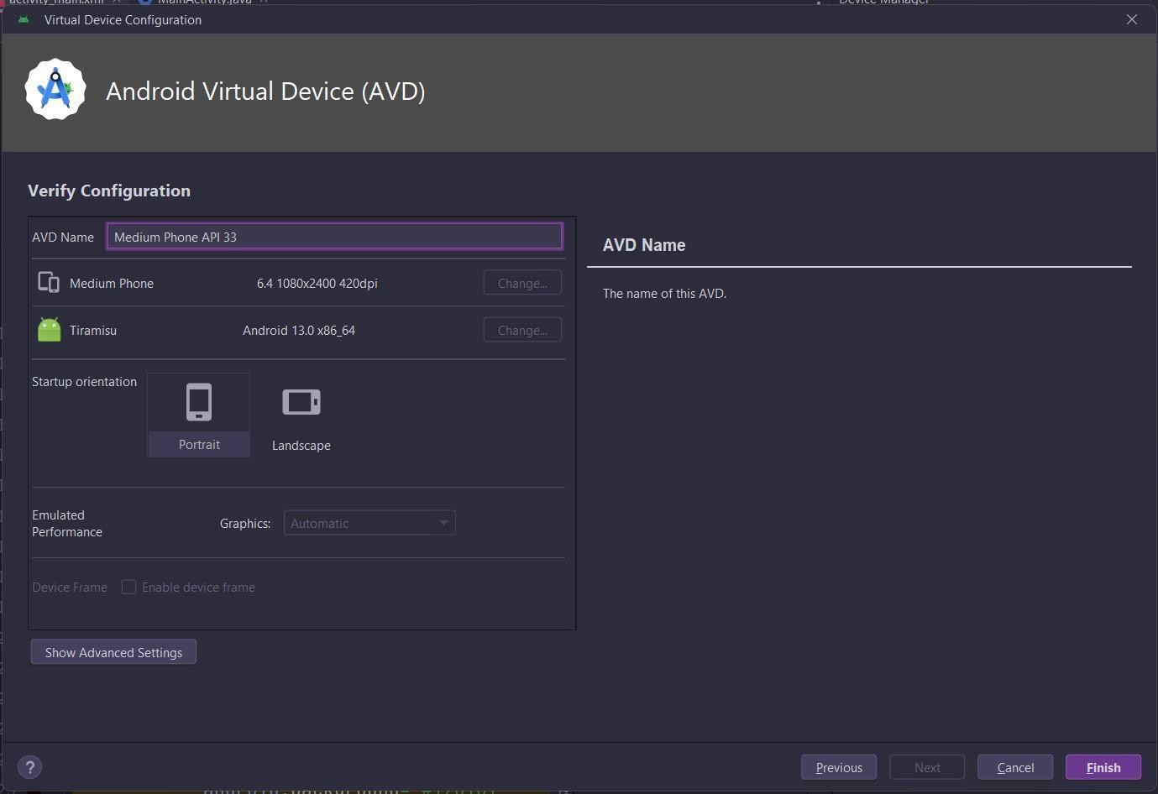

1. In the Your Virtual Devices screen, select the device you just created and click Launch this AVD in the emulator.



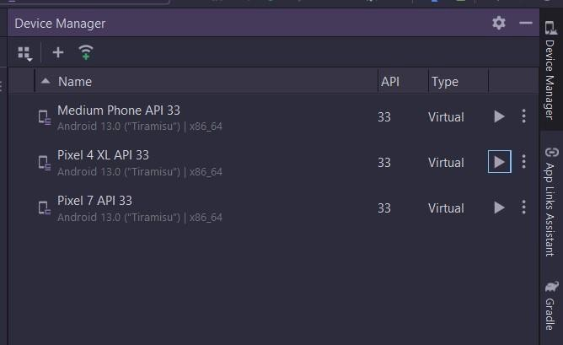

# PRACTICAL 4



## Aim: Develop a program to display Hello World on screen.

**Codes:**

### activity_main.xml code:

<?xml version="1.0" encoding="utf-8"?>

<androidx.constraintlayout.widget.ConstraintLayout xmlns:android="[http://schemas.android.com/apk/res/android"](http://schemas.android.com/apk/res/android)

xmlns:app="[http://schemas.android.com/apk/res-auto"](http://schemas.android.com/apk/res-auto) xmlns:tools="[http://schemas.android.com/tools"](http://schemas.android.com/tools) android:layout_width="match_parent" android:layout_height="match_parent" tools:context=".MainActivity">

<TextView android:layout_width="wrap_content" android:layout_height="wrap_content" android:text="Hello World" android:textSize="30dp" android:textStyle="bold" android:layout_marginTop="280dp" app:layout_constraintTop_toTopOf="parent" app:layout_constraintLeft_toLeftOf="parent"

app:layout_constraintRight_toRightOf="parent"/>

</androidx.constraintlayout.widget.ConstraintLayout>

### MainActivity.java code:

package com.example.pract_4_hello_world;

import androidx.appcompat.app.AppCompatActivity; import android.os.Bundle;

public class MainActivity extends AppCompatActivity {



@Override

protected void onCreate(Bundle savedInstanceState) { super.onCreate(savedInstanceState); setContentView(R.layout.activity_main);

}

}

**Output:**

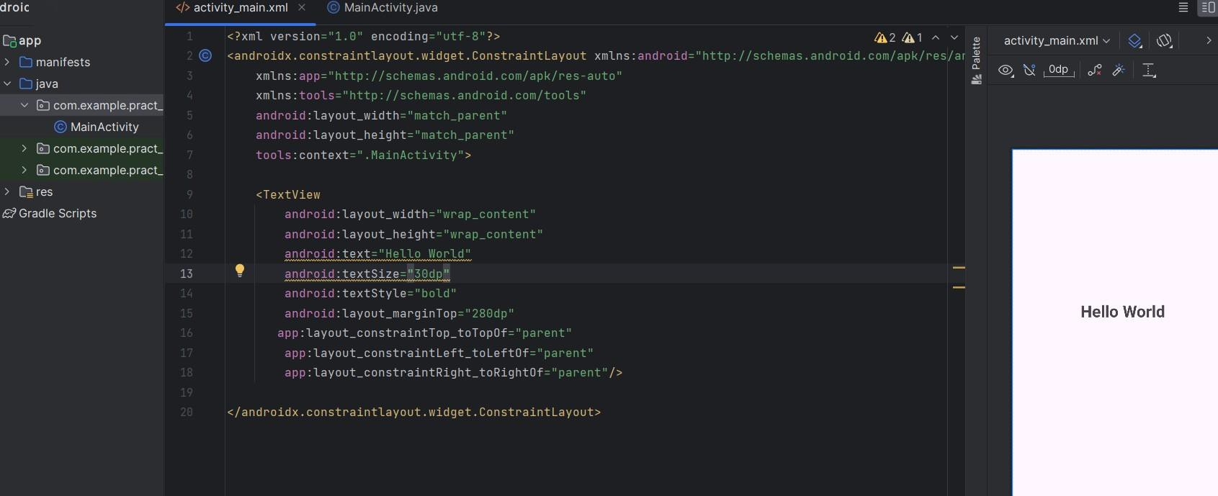

# PRACTICAL 5



## Aim: Develop a program to implement linear layout.

**Code: activity_main.xml**<LinearLayout

xmlns:android="http://schemas.android.com/apk/res/android"

android:layout_width="match_parent"

android:layout_height="match_parent"

android:orientation="vertical"

android:padding="16dp"

android:gravity="center">

<TextView

android:id="@+id/textView"

android:layout_width="wrap_content"

android:layout_height="wrap_content"

android:text="Linear Layout Example"

android:textSize="24sp"

android:layout_marginBottom="16dp"

android:textAlignment="center"

android:textStyle="bold" />

<Button

android:id="@+id/button1"

android:layout_width="wrap_content"

android:layout_height="wrap_content"

android:text="Button 1"

android:layout_marginBottom="8dp" />

<Button

android:id="@+id/button2"

android:layout_width="wrap_content"

android:layout_height="wrap_content"

android:text="Button 2" />

</LinearLayout>

**MainActivity.java**

package com.example.linearlayoutdemo;

import android.os.Bundle;

import androidx.appcompat.app.AppCompatActivity;

public class MainActivity extends AppCompatActivity {

@Override

protected void onCreate(Bundle savedInstanceState) {

super.onCreate(savedInstanceState);

setContentView(R.layout.activity_main);

}

}



**PRACTICAL 6**

**Aim: Develop a program to implement frame layout, table layout and relative layout.**

**Code: activity_frame_layout.xml**

<?xml version="1.0" encoding="utf-8"?>

<FrameLayout

xmlns:android="http://schemas.android.com/apk/res/android"

android:layout_width="match_parent"

android:layout_height="match_parent">

<ImageView

android:id="@+id/imageView"

android:layout_width="match_parent"

android:layout_height="match_parent"

android:src="@drawable/example_image"

android:scaleType="centerCrop" />

<TextView

android:id="@+id/textOverlay"

android:layout_width="wrap_content"

android:layout_height="wrap_content"

android:layout_gravity="center"

android:text="Frame Layout Example"

android:textSize="24sp"

android:textColor="#FFFFFF"

android:background="#80000000"

android:padding="8dp" />

</FrameLayout>

**Code: activity_table_layout.xml**

<?xml version="1.0" encoding="utf-8"?>

<TableLayout

xmlns:android="http://schemas.android.com/apk/res/android"

android:layout_width="match_parent"

android:layout_height="match_parent"

android:stretchColumns="1">

<TableRow>

<TextView

android:layout_width="wrap_content"

android:layout_height="wrap_content"

android:text="Name:"

android:padding="8dp" />

<EditText

android:layout_width="match_parent"

android:layout_height="wrap_content"

android:hint="Enter your name" />

</TableRow>

<TableRow>

<TextView

android:layout_width="wrap_content"

android:layout_height="wrap_content"

android:text="Age:"

android:padding="8dp" />

<EditText

android:layout_width="match_parent"

android:layout_height="wrap_content"

android:hint="Enter your age" />

</TableRow>

<TableRow>

<Button

android:layout_width="wrap_content"

android:layout_height="wrap_content"

android:text="Submit"

android:layout_span="2"

android:gravity="center" />

</TableRow>

</TableLayout>



**Code: activity_relative_layout.xml**

<?xml version="1.0" encoding="utf-8"?>

<RelativeLayout

xmlns:android="http://schemas.android.com/apk/res/android"

android:layout_width="match_parent"

android:layout_height="match_parent"

android:padding="16dp">

<TextView

android:id="@+id/labelText"

android:layout_width="wrap_content"

android:layout_height="wrap_content"

android:text="Relative Layout Example"

android:textSize="24sp"

android:textStyle="bold"

android:layout_centerHorizontal="true" />

<Button

android:id="@+id/button1"

android:layout_width="wrap_content"

android:layout_height="wrap_content"

android:text="Button 1"

android:layout_below="@id/labelText"

android:layout_marginTop="16dp"

android:layout_alignParentStart="true" />

<Button

android:id="@+id/button2"

android:layout_width="wrap_content"

android:layout_height="wrap_content"

android:text="Button 2"

android:layout_toEndOf="@id/button1"

android:layout_below="@id/labelText"

android:layout_marginStart="8dp"

android:layout_marginTop="16dp" />

</RelativeLayout

**PRACTICAL** **7**



## Aim: Create an application that takes the name from a text box and shows hello message along with the name entered in text box, when the user clicks the OK button

**Codes:**

#### activity_practical7.xml Code:

<RelativeLayout xmlns:android="<http://schemas.android.com/apk/res/android>" xmlns:tools="[http://schemas.android.com/tools"](http://schemas.android.com/tools) android:layout_width="match_parent" android:layout_height="match_parent" android:padding="16dp">

<EditText android:id="@+id/editTextName" android:layout_width="match_parent" android:layout_height="wrap_content" android:hint="Enter your name" android:inputType="text" android:layout_marginBottom="16dp"/>

<Button

android:id="@+id/buttonOK" android:layout_width="wrap_content" android:layout_height="wrap_content" android:layout_below="@id/editTextName" android:layout_centerHorizontal="true" android:text="OK"/>

<TextView android:id="@+id/textViewMessage" android:layout_width="wrap_content" android:layout_height="wrap_content" android:layout_below="@id/buttonOK" android:layout_centerHorizontal="true" android:layout_marginTop="16dp" android:text="" android:textSize="18sp"/>

</RelativeLayout>

#### Practical7Activity.java Code:

package com.priyamtripz.mad;

import androidx.appcompat.app.AppCompatActivity; import android.os.Bundle;

import android.view.View; import android.widget.Button; import android.widget.EditText; import android.widget.TextView;



public class Practical7Activity extends AppCompatActivity { EditText editTextName;

Button buttonOK;

TextView textViewMessage; @Override

protected void onCreate(Bundle savedInstanceState) { super.onCreate(savedInstanceState); setContentView(R.layout.activity_practical7); editTextName = findViewById(R.id.editTextName); buttonOK = findViewById(R.id.buttonOK); textViewMessage = findViewById(R.id.textViewMessage);

buttonOK.setOnClickListener(new View.OnClickListener() { @Override

public void onClick(View v) {

String name = editTextName.getText().toString(); String message = "Hello, " + name + "!"; textViewMessage.setText(message);

}

});

}

}

**Output:**

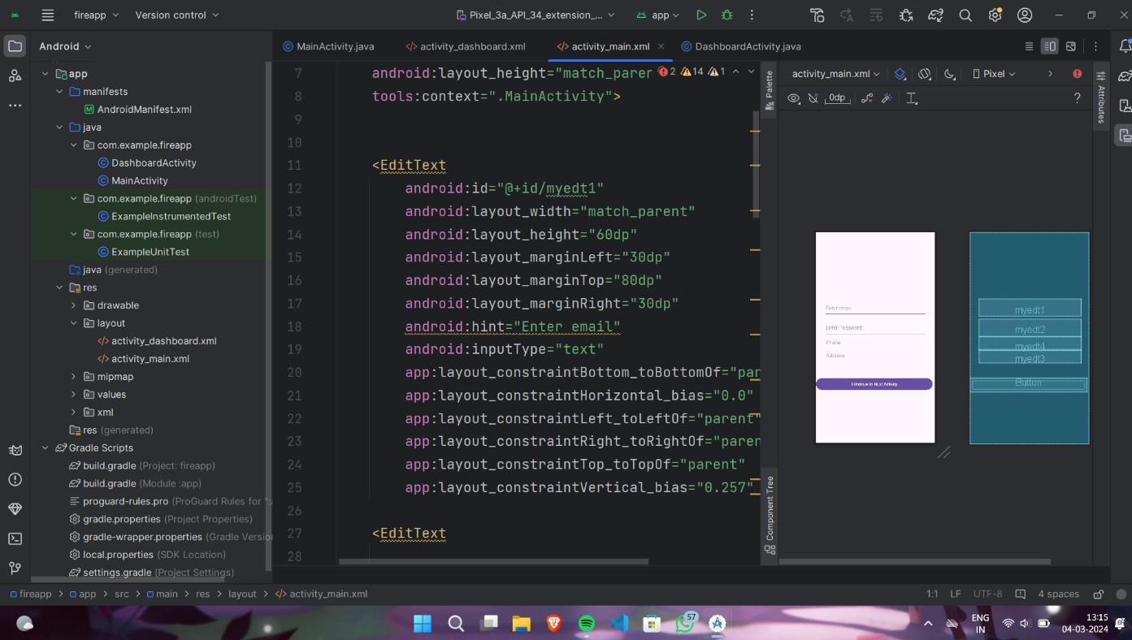

# PRACTICAL 8



## Aim: Create a screen that has input boxes for User Name, Password, Address, Gender (radio buttons for male and female), Age (numeric), Date of Birth (Date Picket) and a Submit button. On clicking the submit button, print all the data below the Submit Button (use any layout)

**Codes:**

#### activity_practical8.xml code:

<ScrollView xmlns:android="<http://schemas.android.com/apk/res/android>" xmlns:tools="[http://schemas.android.com/tools"](http://schemas.android.com/tools) android:layout_width="match_parent" android:layout_height="match_parent"

android:padding="16dp">

<LinearLayout android:layout_width="match_parent" android:layout_height="wrap_content" android:orientation="vertical">

<EditText android:id="@+id/editTextUserName" android:layout_width="match_parent" android:layout_height="wrap_content" android:hint="User Name" android:inputType="text"/>

<EditText android:id="@+id/editTextPassword" android:layout_width="match_parent" android:layout_height="wrap_content" android:hint="Password" android:inputType="textPassword"/>

<EditText android:id="@+id/editTextAddress" android:layout_width="match_parent" android:layout_height="wrap_content" android:hint="Address" android:inputType="text"/>

<RadioGroup android:id="@+id/radioGroupGender" android:layout_width="match_parent" android:layout_height="wrap_content" android:orientation="horizontal">

<RadioButton android:id="@+id/radioButtonMale"

android:layout_width="wrap_content" android:layout_height="wrap_content" android:text="Male"/>



<RadioButton android:id="@+id/radioButtonFemale" android:layout_width="wrap_content" android:layout_height="wrap_content" android:text="Female"/>

</RadioGroup>

<EditText android:id="@+id/editTextAge" android:layout_width="match_parent" android:layout_height="wrap_content" android:hint="Age" android:inputType="number"/>

<DatePicker android:id="@+id/datePickerDOB" android:layout_width="match_parent" android:layout_height="wrap_content"/>

<Button

android:id="@+id/buttonSubmit" android:layout_width="wrap_content" android:layout_height="wrap_content" android:text="Submit"/>

<TextView android:id="@+id/textViewData" android:layout_width="match_parent" android:layout_height="wrap_content" android:layout_marginTop="16dp" android:text="" android:textSize="18sp"/>

</LinearLayout>

</ScrollView>

#### Practical8Activity.java code:

package com.priyamtripz.mad;

import androidx.appcompat.app.AppCompatActivity; import android.os.Bundle;

import android.view.View; import android.widget.Button;

import android.widget.DatePicker; import android.widget.EditText; import android.widget.RadioButton; import android.widget.RadioGroup; import android.widget.TextView;



public class Practical8Activity extends AppCompatActivity {

EditText editTextUserName, editTextPassword, editTextAddress, editTextAge; RadioGroup radioGroupGender;

RadioButton radioButtonMale, radioButtonFemale; DatePicker datePickerDOB;

Button buttonSubmit; TextView textViewData; @Override

protected void onCreate(Bundle savedInstanceState) { super.onCreate(savedInstanceState); setContentView(R.layout.activity_practical8);

editTextUserName = findViewById(R.id.editTextUserName); editTextPassword = findViewById(R.id.editTextPassword); editTextAddress = findViewById(R.id.editTextAddress); editTextAge = findViewById(R.id.editTextAge); radioGroupGender = findViewById(R.id.radioGroupGender); radioButtonMale = findViewById(R.id.radioButtonMale); radioButtonFemale = findViewById(R.id.radioButtonFemale); datePickerDOB = findViewById(R.id.datePickerDOB); buttonSubmit = findViewById(R.id.buttonSubmit); textViewData = findViewById(R.id.textViewData);

buttonSubmit.setOnClickListener(new View.OnClickListener() { @Override

public void onClick(View v) {

String userName = editTextUserName.getText().toString(); String password = editTextPassword.getText().toString(); String address = editTextAddress.getText().toString(); String age = editTextAge.getText().toString();

String gender = radioButtonMale.isChecked() ? "Male" : "Female"; String dob = getDateFromDatePicker(datePickerDOB);

String data = "User Name: " + userName + "\n" + "Password: " + password + "\n" +

"Address: " + address + "\n" + "Gender: " + gender + "\n" + "Age: " + age + "\n" +

"Date of Birth: " + dob;

textViewData.setText(data);

}

});

}

private String getDateFromDatePicker(DatePicker datePicker) { int day = datePicker.getDayOfMonth();

int month = datePicker.getMonth() + 1; int year = datePicker.getYear();

return day + "/" + month + "/" + year;

}

}



**Output:**

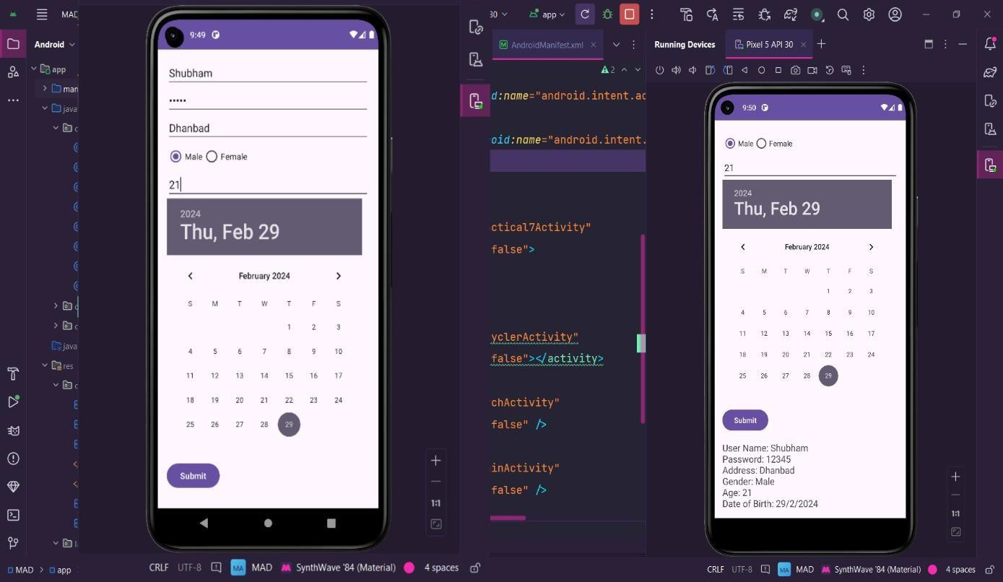

# PRACTICAL 9



## Aim: Design an android application to create page using Intent and one Button and pass the Values from one Activity to second Activity

**Codes:**

#### activity_main.xml code:

<?xml version="1.0" encoding="utf-8"?>

<androidx.constraintlayout.widget.ConstraintLayout xmlns:android="<http://schemas.android.com/apk/res/android>" xmlns:app="[http://schemas.android.com/apk/res-auto"](http://schemas.android.com/apk/res-auto) xmlns:tools="[http://schemas.android.com/tools"](http://schemas.android.com/tools) android:layout_width="match_parent" android:layout_height="match_parent">

<EditText android:id="@+id/etuser"

android:layout_width="match_parent" android:layout_height="wrap_content" app:layout_constraintRight_toRightOf="parent" app:layout_constraintLeft_toLeftOf="parent" app:layout_constraintTop_toTopOf="parent" android:hint="Enter Data" android:textSize="20sp" android:textColor="@color/black" android:layout_marginLeft="30dp" android:layout_marginRight="30dp" android:layout_marginTop="100dp"/>

<Button

android:id="@+id/databtn" android:layout_width="wrap_content" android:layout_height="wrap_content" app:layout_constraintRight_toRightOf="parent" app:layout_constraintLeft_toLeftOf="parent" app:layout_constraintBottom_toBottomOf="parent" android:text="SUBMIT"

android:textSize="25sp" android:layout_marginLeft="30dp" android:layout_marginRight="30dp" android:layout_marginBottom="200dp"/>

</androidx.constraintlayout.widget.ConstraintLayout>

#### MainActivity.java Code:

package com.priyamtripz.mad;

import androidx.appcompat.app.AppCompatActivity; import android.content.Intent;

import android.os.Bundle;

import android.view.View; import android.widget.Button; import android.widget.EditText; import android.widget.Toast;



public class MainActivity extends AppCompatActivity { EditText editText;

Button submitbtn; @Override

protected void onCreate(Bundle savedInstanceState) { super.onCreate(savedInstanceState); setContentView(R.layout.activity_main);

editText = findViewById(R.id.etuser); submitbtn = findViewById(R.id.databtn);

submitbtn.setOnClickListener(new View.OnClickListener() { @Override

public void onClick(View view) {

String name = editText.getText().toString();

Intent intent = new Intent(MainActivity.this, FetchActivity.class); intent.putExtra("data", name );

startActivity(intent);

}

});

}

#### activity_fetch.xml code:

<LinearLayout xmlns:android="<http://schemas.android.com/apk/res/android>" xmlns:tools="[http://schemas.android.com/tools"](http://schemas.android.com/tools) android:layout_width="match_parent" android:orientation="vertical" android:layout_height="match_parent" android:gravity="center"

android:padding="16dp">

<TextView android:id="@+id/textViewDisplay" android:layout_width="wrap_content" android:layout_height="wrap_content" android:textSize="30sp" android:textColor="@android:color/black"/>

</LinearLayout>



#### FetchActivity.java code:

package com.priyamtripz.mad;

import androidx.appcompat.app.AppCompatActivity; import android.content.Intent;

import android.os.Bundle; import android.view.View; import android.widget.Button; import android.widget.EditText;

import android.widget.TextView;

public class FetchActivity extends AppCompatActivity { TextView textViewDisplay;

@Override

protected void onCreate(Bundle savedInstanceState) { super.onCreate(savedInstanceState); setContentView(R.layout.activity_fetch); textViewDisplay = findViewById(R.id.textViewDisplay); Intent intent = getIntent();

if (intent != null && intent.hasExtra("data")) { String inputText = intent.getStringExtra("data"); textViewDisplay.setText(inputText);

}

}

}

**Output:**

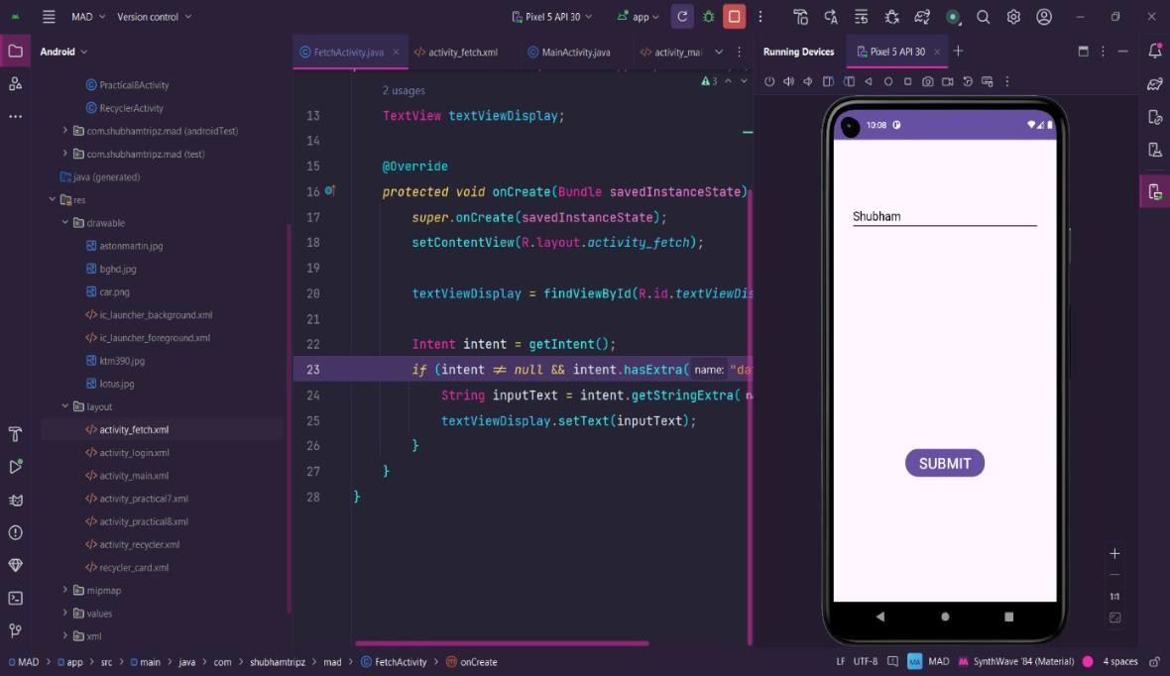

**PRACTICAL 10**

**Aim : Design an android application Send SMS using Intent.**

**activity-main.xml:**  
  
<?xml version="1.0" encoding="utf-8"?>

<LinearLayout

xmlns:android="http://schemas.android.com/apk/res/android"

android:layout_width="match_parent"

android:layout_height="match_parent"

android:orientation="vertical"

android:padding="16dp">

<EditText

android:id="@+id/phoneNumber"

android:layout_width="match_parent"

android:layout_height="wrap_content"

android:hint="Enter phone number"

android:inputType="phone" />

<EditText

android:id="@+id/messageText"

android:layout_width="match_parent"

android:layout_height="wrap_content"

android:hint="Enter message"

android:inputType="textMultiLine"

android:layout_marginTop="8dp" />

<Button

android:id="@+id/sendButton"

android:layout_width="match_parent"

android:layout_height="wrap_content"

android:text="Send SMS"

android:layout_marginTop="16dp" />

</LinearLayout>

**MainActivity.java:**

package com.example.sendsms;

import android.content.Intent;

import android.net.Uri;

import android.os.Bundle;

import android.view.View;

import android.widget.Button;

import android.widget.EditText;

import android.widget.Toast;

import androidx.appcompat.app.AppCompatActivity;

public class MainActivity extends AppCompatActivity {

@Override

protected void onCreate(Bundle savedInstanceState) {

super.onCreate(savedInstanceState);

setContentView(R.layout.activity_main);

EditText phoneNumber = findViewById(R.id.phoneNumber);

EditText messageText = findViewById(R.id.messageText);

Button sendButton = findViewById(R.id.sendButton);

sendButton.setOnClickListener(new View.OnClickListener() {

@Override

public void onClick(View v) {

String phone = phoneNumber.getText().toString();

String message = messageText.getText().toString();

if (phone.isEmpty() || message.isEmpty()) {

Toast.makeText(MainActivity.this, "Please fill in both fields", Toast.LENGTH_SHORT).show();

} else {

Intent intent = new Intent(Intent.ACTION_VIEW);

intent.setData(Uri.parse("sms:" + phone));

intent.putExtra("sms_body", message);

try {

startActivity(intent);

} catch (Exception e) {

Toast.makeText(MainActivity.this, "SMS sending failed", Toast.LENGTH_SHORT).show();

}

}

}

});

}

}

**PRACTICAL 11**

**Aim : Create an android application using Fragments.  
  
activity-main.xml:**

<?xml version="1.0" encoding="utf-8"?>

<LinearLayout

xmlns:android="http://schemas.android.com/apk/res/android"

android:layout_width="match_parent"

android:layout_height="match_parent"

android:orientation="vertical">

<LinearLayout

android:layout_width="match_parent"

android:layout_height="wrap_content"

android:orientation="horizontal"

android:gravity="center">

<Button

android:id="@+id/buttonFragment1"

android:layout_width="wrap_content"

android:layout_height="wrap_content"

android:text="Show Fragment 1"

android:layout_margin="8dp" />

<Button

android:id="@+id/buttonFragment2"

android:layout_width="wrap_content"

android:layout_height="wrap_content"

android:text="Show Fragment 2"

android:layout_margin="8dp" />

</LinearLayout>

<FrameLayout

android:id="@+id/fragmentContainer"

android:layout_width="match_parent"

android:layout_height="match_parent"

android:layout_marginTop="16dp" />

</LinearLayout>

**fragment-one.xml:**

<?xml version="1.0" encoding="utf-8"?>

<LinearLayout

xmlns:android="http://schemas.android.com/apk/res/android"

android:layout_width="match_parent"

android:layout_height="match_parent"

android:orientation="vertical"

android:gravity="center"

android:padding="16dp"

android:background="#FFDDC1">

<TextView

android:layout_width="wrap_content"

android:layout_height="wrap_content"

android:text="This is Fragment 1"

android:textSize="24sp"

android:textStyle="bold" />

</LinearLayout>

**fragment-two.xml:**<?xml version="1.0" encoding="utf-8"?>

<LinearLayout

xmlns:android="http://schemas.android.com/apk/res/android"

android:layout_width="match_parent"

android:layout_height="match_parent"

android:orientation="vertical"

android:gravity="center"

android:padding="16dp"

android:background="#C1E1FF">

<TextView

android:layout_width="wrap_content"

android:layout_height="wrap_content"

android:text="This is Fragment 2"

android:textSize="24sp"

android:textStyle="bold" />

</LinearLayout>

**FragmentOne.java**

package com.example.fragmentdemo;

import android.os.Bundle;

import androidx.fragment.app.Fragment;

import android.view.LayoutInflater;

import android.view.View;

import android.view.ViewGroup;

public class FragmentOne extends Fragment {

@Override

public View onCreateView(LayoutInflater inflater, ViewGroup container,

Bundle savedInstanceState) {

// Inflate the layout for this fragment

return inflater.inflate(R.layout.fragment_one, container, false);

}

}

**FragmentTwo.java**

package com.example.fragmentdemo;

import android.os.Bundle;

import androidx.fragment.app.Fragment;

import android.view.LayoutInflater;

import android.view.View;

import android.view.ViewGroup;

public class FragmentTwo extends Fragment {

@Override

public View onCreateView(LayoutInflater inflater, ViewGroup container,

Bundle savedInstanceState) {

// Inflate the layout for this fragment

return inflater.inflate(R.layout.fragment_two, container, false);

}

}

**MainActivity.java**

package com.example.fragmentdemo;

import android.os.Bundle;

import android.view.View;

import android.widget.Button;

import androidx.appcompat.app.AppCompatActivity;

import androidx.fragment.app.Fragment;

import androidx.fragment.app.FragmentTransaction;

public class MainActivity extends AppCompatActivity {

@Override

protected void onCreate(Bundle savedInstanceState) {

super.onCreate(savedInstanceState);

setContentView(R.layout.activity_main);

Button buttonFragment1 = findViewById(R.id.buttonFragment1);

Button buttonFragment2 = findViewById(R.id.buttonFragment2);

buttonFragment1.setOnClickListener(new View.OnClickListener() {

@Override

public void onClick(View v) {

loadFragment(new FragmentOne());

}

});

buttonFragment2.setOnClickListener(new View.OnClickListener() {

@Override

public void onClick(View v) {

loadFragment(new FragmentTwo());

}

});

// Load the first fragment by default

loadFragment(new FragmentOne());

}

private void loadFragment(Fragment fragment) {

FragmentTransaction transaction = getSupportFragmentManager().beginTransaction();

transaction.replace(R.id.fragmentContainer, fragment);

transaction.commit();

}

}

**PRACTICAL 12**

**Aim: Design an android application Using Radio button.**

**activity-main.xml:**

<?xml version="1.0" encoding="utf-8"?>

<LinearLayout

xmlns:android="http://schemas.android.com/apk/res/android"

android:layout_width="match_parent"

android:layout_height="match_parent"

android:orientation="vertical"

android:padding="16dp">

<TextView

android:layout_width="wrap_content"

android:layout_height="wrap_content"

android:text="Select Your Favorite Programming Language:"

android:textSize="18sp"

android:layout_marginBottom="16dp" />

<RadioGroup

android:id="@+id/radioGroup"

android:layout_width="match_parent"

android:layout_height="wrap_content"

android:orientation="vertical">

<RadioButton

android:id="@+id/radioJava"

android:layout_width="wrap_content"

android:layout_height="wrap_content"

android:text="Java" />

<RadioButton

android:id="@+id/radioPython"

android:layout_width="wrap_content"

android:layout_height="wrap_content"

android:text="Python" />

<RadioButton

android:id="@+id/radioCpp"

android:layout_width="wrap_content"

android:layout_height="wrap_content"

android:text="C++" />

<RadioButton

android:id="@+id/radioKotlin"

android:layout_width="wrap_content"

android:layout_height="wrap_content"

android:text="Kotlin" />

</RadioGroup>

<Button

android:id="@+id/submitButton"

android:layout_width="wrap_content"

android:layout_height="wrap_content"

android:text="Submit"

android:layout_marginTop="16dp" />

<TextView

android:id="@+id/resultText"

android:layout_width="match_parent"

android:layout_height="wrap_content"

android:text=""

android:textSize="16sp"

android:textStyle="bold"

android:layout_marginTop="16dp"

android:gravity="center" />

</LinearLayout>

**MainActivity.java**

package com.example.radiobuttondemo;

import android.os.Bundle;

import android.view.View;

import android.widget.Button;

import android.widget.RadioButton;

import android.widget.RadioGroup;

import android.widget.TextView;

import android.widget.Toast;

import androidx.appcompat.app.AppCompatActivity;

public class MainActivity extends AppCompatActivity {

@Override

protected void onCreate(Bundle savedInstanceState) {

super.onCreate(savedInstanceState);

setContentView(R.layout.activity_main);

RadioGroup radioGroup = findViewById(R.id.radioGroup);

Button submitButton = findViewById(R.id.submitButton);

TextView resultText = findViewById(R.id.resultText);

submitButton.setOnClickListener(new View.OnClickListener() {

@Override

public void onClick(View v) {

int selectedId = radioGroup.getCheckedRadioButtonId();

if (selectedId == -1) {

// No radio button selected

Toast.makeText(MainActivity.this, "Please select an option", Toast.LENGTH_SHORT).show();

} else {

RadioButton selectedRadioButton = findViewById(selectedId);

String selectedText = selectedRadioButton.getText().toString();

resultText.setText("You selected: " + selectedText);

}

}

});

}

}

**PRACTICAL 13**

**Aim: Design an android application for menu.  
  
 activity-main.xml:**

<?xml version="1.0" encoding="utf-8"?>

<LinearLayout

xmlns:android="http://schemas.android.com/apk/res/android"

android:layout_width="match_parent"

android:layout_height="match_parent"

android:orientation="vertical"

android:gravity="center"

android:padding="16dp">

<TextView

android:layout_width="wrap_content"

android:layout_height="wrap_content"

android:text="Welcome to Menu Demo"

android:textSize="20sp"

android:textStyle="bold"

android:layout_marginBottom="16dp" />

<TextView

android:id="@+id/displayText"

android:layout_width="wrap_content"

android:layout_height="wrap_content"

android:text="Select an option from the menu"

android:textSize="16sp"

android:layout_marginTop="16dp" />

</LinearLayout>

**res/menu – main-menu.xml**

<?xml version="1.0" encoding="utf-8"?>

<menu xmlns:android="http://schemas.android.com/apk/res/android">

<item

android:id="@+id/action_home"

android:title="Home"

android:icon="@android:drawable/ic_menu_view"

android:showAsAction="ifRoom" />

<item

android:id="@+id/action_settings"

android:title="Settings"

android:icon="@android:drawable/ic_menu_manage"

android:showAsAction="ifRoom" />

<item

android:id="@+id/action_about"

android:title="About"

android:icon="@android:drawable/ic_menu_info_details"

android:showAsAction="never" />

</menu>

**MainActivity.java:**

package com.example.menudemo;

import android.os.Bundle;

import android.view.Menu;

import android.view.MenuItem;

import android.widget.TextView;

import android.widget.Toast;

import androidx.appcompat.app.AppCompatActivity;

public class MainActivity extends AppCompatActivity {

private TextView displayText;

@Override

protected void onCreate(Bundle savedInstanceState) {

super.onCreate(savedInstanceState);

setContentView(R.layout.activity_main);

displayText = findViewById(R.id.displayText);

}

@Override

public boolean onCreateOptionsMenu(Menu menu) {

// Inflate the menu

getMenuInflater().inflate(R.menu.main_menu, menu);

return true;

}

@Override

public boolean onOptionsItemSelected(MenuItem item) {

switch (item.getItemId()) {

case R.id.action_home:

displayText.setText("Home selected");

Toast.makeText(this, "Home clicked", Toast.LENGTH_SHORT).show();

return true;

case R.id.action_settings:

displayText.setText("Settings selected");

Toast.makeText(this, "Settings clicked", Toast.LENGTH_SHORT).show();

return true;

case R.id.action_about:

displayText.setText("About selected");

Toast.makeText(this, "About clicked", Toast.LENGTH_SHORT).show();

return true;

default:

return super.onOptionsItemSelected(item);

}

}

}